ST10529147
NEO LEBITSA

Exploratory Data Analytics
Step 1: Importing required libraries.
Import libraries like NumPy, Pandas,Seaborn and Matplotlib.
Step 2: Download and upload dataset.
Download the dataset as the csv file and upload it to the Jupyter notebook.
Step 3: Structure and size
The dataset consists of 7 columns and 1337 rows which contain enough data for analysis. The data is structured and easy to analyse.
Step 4: Data types

Column name | Description | Data type
Age | Numerical data that show the age of individual insured. | Independent (Integer64)
Sex | category | independent(object64)
BMI | Numerical | Independent(float64)
Children | Numerical | Independent(integer64)
Region | Category | Independent(object64)
Smoker | Category | Independent(boolean64)
Charges | Numerical | Dependent(float64)

Step 5:Missing and duplicate values
The dataset has no missing values, however, it has 0 duplicate values.

Step 6: Outliers
About 44 outliers were detected

Step 7: Value distribution
There is a significant variance in the dataset values.

Step 8: Bias representation
There is bias representation as the dataset shows the presence of outliers.

Feature selection

The following columns will be used as predictors ( age, bmi, region, children, sex, and smoker). The charges are the outcome of the predictions. The pairplot will be constructed to determine which parameters have the linear relationship. Therefore age will be used as the x-variable and charges as the y-variable. The p value, correlation targets and the variance will be considered when choosing the models.

Train model

The model will be trained using the Linear regression model.80% of the dataset will be used to train the model and 20% of the dataset will be used to test the data. The dataset contains about 1338 rows, which is suitable for training and testing the model with 20%.

Interpreting the model’s performance

The dataset consists of 1338 rows and 7 columns. EDA was conducted, there were no null values found and one duplicate value was found and removed. The charges column contained the float value which was later converted into an integer for model training.
Results of testing the model. l, as well as the 80% used for model training and 20% model testing.The dataset contains about 1338 rows, which is suitable for training and testing the model with 20%.how well the model fits the dataset. The dataset had one duplicate and no null values.
The pairplot (Figure 1) was constructed and the age vs charges graph showed more correlation compared to other independent variables. There is a correlation between the bmi and charges, whereas there is no correlation between children and charges. Therefore children, bmi, region and smoker were excluded when training the model. Multicollinearity was not observed from this dataset since there is no strong correlation between input features(Vatcheva, P.k., Lee, M., McCornick, J.B., Rahbar, M.H, 2016).

The model was trained using X=”age” and y=”charges” and the equation of the linear graph is y=257.2297x +3190.0219. The Mean Square Error (SME) is 166275353.3341, which shows that the model performs poorly. The MSE compares the predicted values to the actual values, to determine how well the model performs. The huge MSE value suggests that the model overfits the data. The model might have learned from the noise or memorised the training data, which leads to inaccurate model training. Outliers could be another factor that affects the training of the model, leading to biassed results.

The model does not properly fit the dataset. The mean square error is also huge, which suggests that the model does not fit the dataset and there is less accuracy. MSE shows that the model is biassed and the variance is also big, showing that the model overfits the dataset. The R^2 score is 0.09513, this depicts that few data points lie on the line of best fit, and the rest of the datapoints are far from the line of best fit. The scatterplot (Figure:2) below shows how the line of best fit fits the dataset. The best line of fit does not fit the dataset, only about 6 datapoints lie on the best fit line. The datapoints are aggregated and there are few outliers. The age ranges between 18-64 and there are not many data points over the age of 60. About 44 of the outliers were found from the dataset.

Conclusion
The model does not fit the data set properly and also contains a large SME value. The model will then be regulated using (L2) and loss function to reduce the large SME and coefficient. The model is inaccurate and might have learned from the noise.The values of the data points can also be changed randomly to reduce the coefficient.
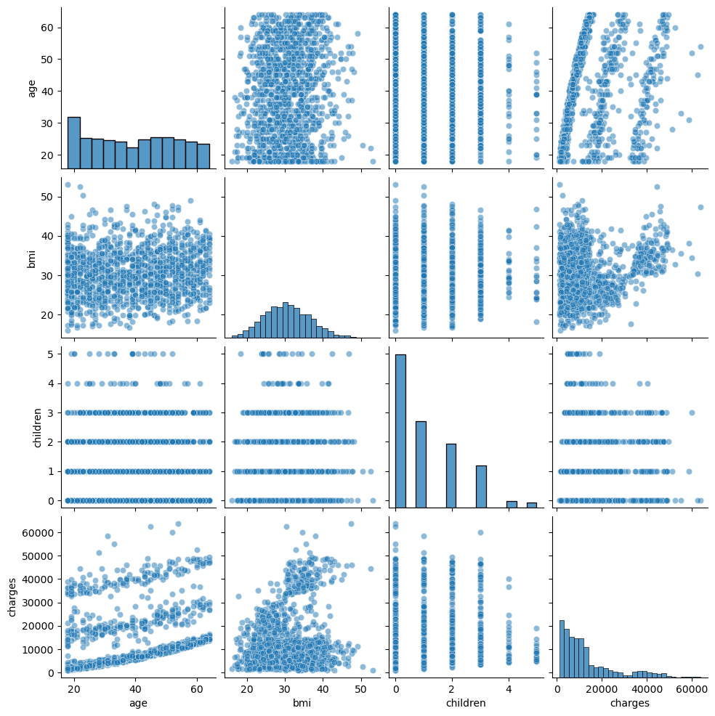
Figure 1: Pairplot showing relationship between the input variables(x) and outcome variable(y).

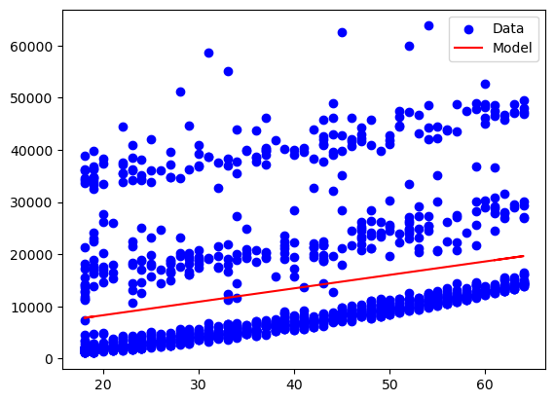
Figure 2: Scatterplot diagram of age and charges

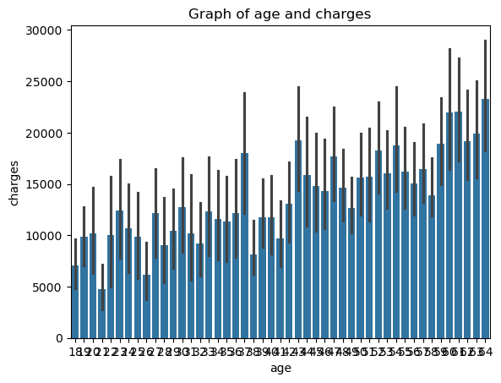
Figure 3: Bargraph plot of age and charges.

Reference
Vatcheva, P.k., Lee, M., McCornick, J.B., Rahbar, M.H. 2016. Epidemiology (Sunnyvale). Author manuscript; available in PMC: .Published in final edited form as: Epidemiology (Sunnyvale).;6(2):227.
doi: 10.4172/2161-1165.1000227

James, A. 2023. An Introduction to Statistical Learning, Springer Texts in Statistics, https://doi.org/10.1007/978-3-031-38747-0_3 69 70 3

